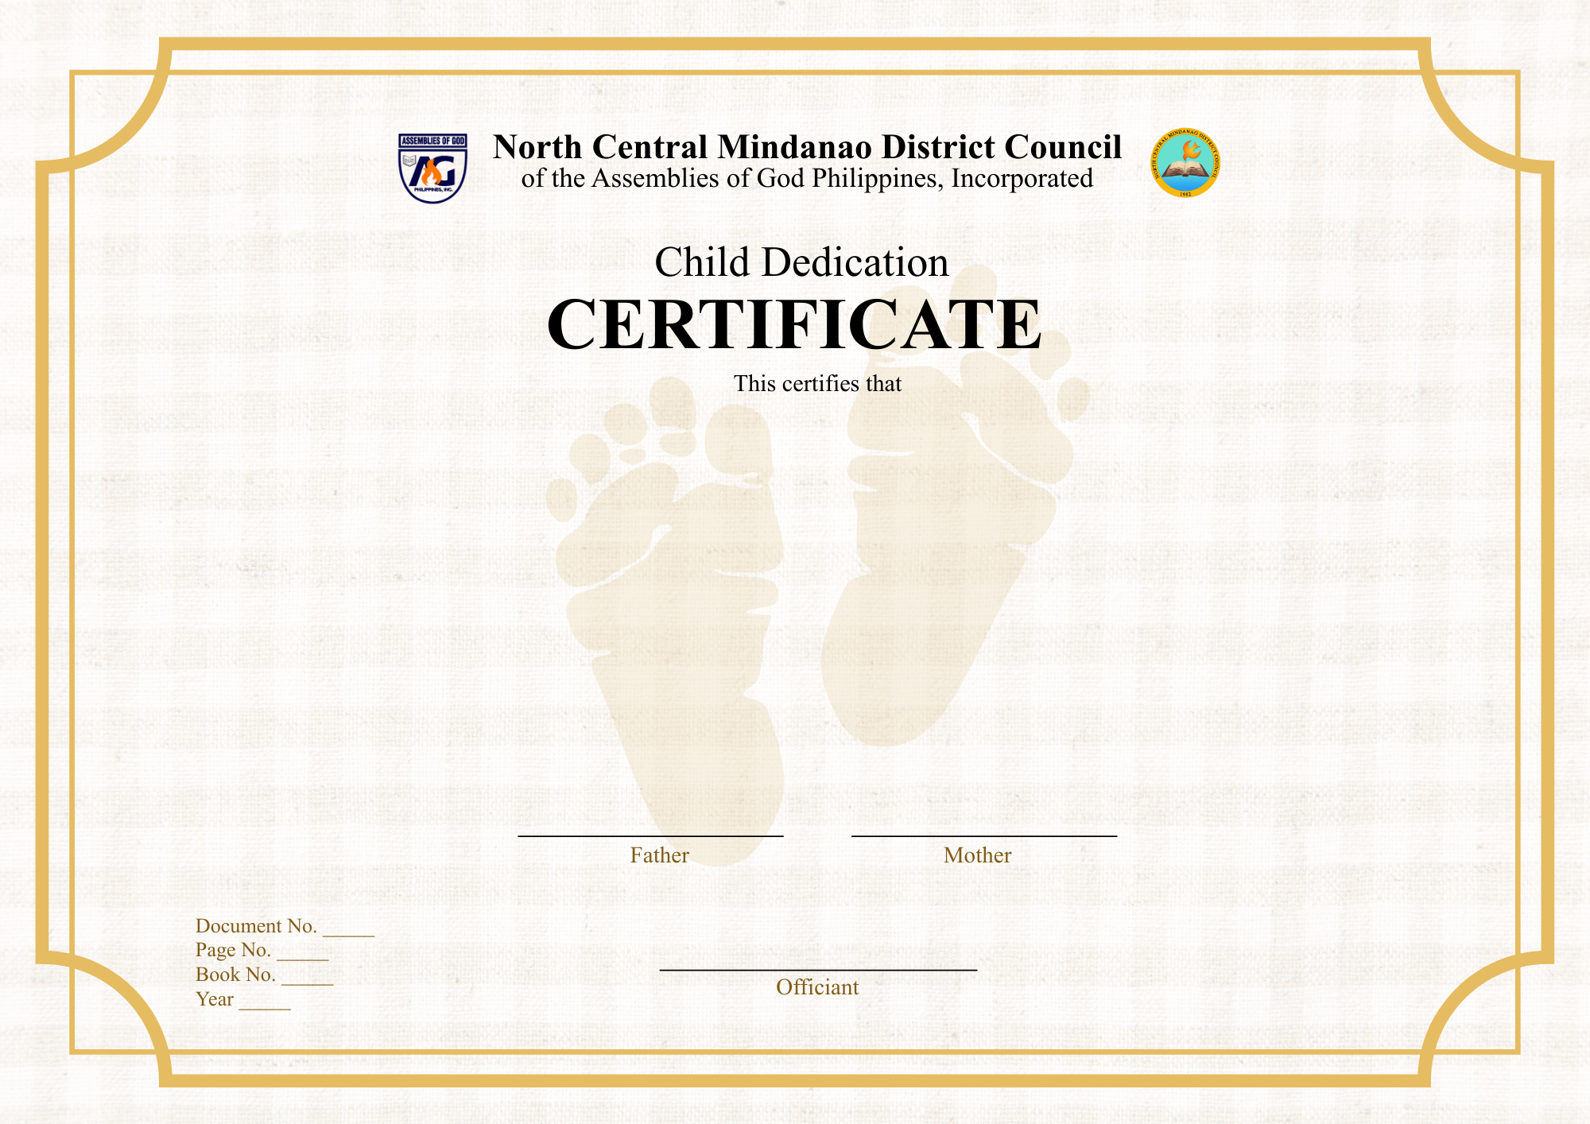
PS. LLOYD C. YANA
2026
1
1
001
Mrs. Jovelyn S. Yana
Born on March 6, 2027, in Nazareth, Cagayan de Oro City,
a Filipino child, son of Mr. Lloyd C. Yana and Mrs. Jovelyn S. Yana,
residing at Graceville Subdivision, Mambuaya, Cagayan de Oro City,
was joyfully presented and dedicated to God on March 6, 2028 at
The Savior’s Assembly, Sinaloc, El Salvador City.
In this sacred dedication, the parents commit to raise their child in faith, love,
and godly instruction, trusting the Lord’s guidance and blessings upon her life.
El Roi S. Yana
Mr. Lloyd C. Yana

